**Unit 8 - Extension task – Business applications of social media**

**Companies which have massive impact on social media?**

Many companies use social media to promote and advertise their products. In 2020, the top 6 companies which had the highest rate of impact on social media were: GoPro, Nike, Spotify, Wayfair, Starbucks, and national geographic.

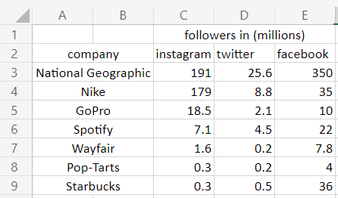

As you shown in the screenshot above, I have created a table. This table shows Beside each company, there is a value which stands for the number of followers which the company has and above in the column shows which social media platform on. The figures in my table are the most recent updates of followers since 11/2021. We can see that the company National Geographic has the most followers on Instagram (191,000,000). Compared to the other 5 companies in this table, national geographic also has the most followers on twitter. (250,600,000). The nation's monthly magazine also has the greatest number of followers on Facebook. However, I think Samsung has a bigger impact on social media to this day, Therefore I will l speak about Samsung.

**What is the business and who are they?**

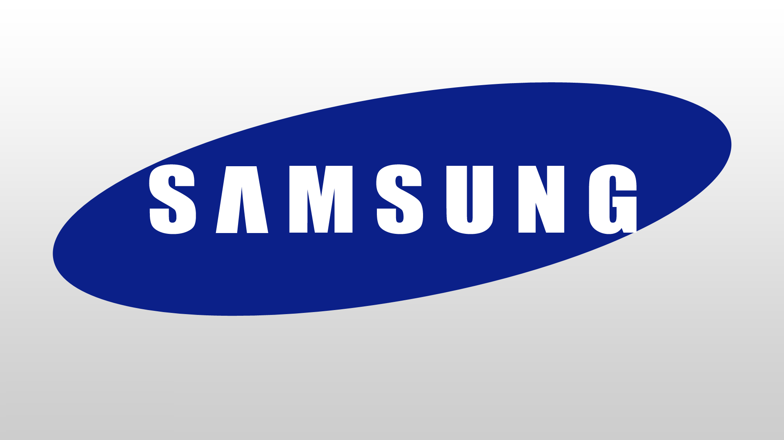

Samsung is a well know brand for its electronic devices. Samsung is the world’s second highest electronic device manufacturer behind Apple in first place. By 2017, Samsung was ranked 6th for having the most valuable brand. Samsung is highly known for its sales of smartphones. They also sell many other products such as: Tv, Tablets, Smartwatches, Smartphones, desktops, monitors, computers, laptops, Speakers and many more.

Samsung was founded in south Korea in the early 1938 by a man named Lee Byung – chul. He started his business in Korea by selling goods. After the Korean War he managed to expand his grocery trading store to a large wooden mill, and he opened a business in textiles. By the 1970’s he was able to produce products such as black and white Tv’s. Lee eventually died in 1987 and his son took over the business. Samsung has massively grown till today. Annual statistics show that from 2005 – 2018, Samsung managed to make revenue of 243.77 trillion Korean won equivalent to 218 billion USD. I got these stats from this link. ([www.statista.com/statistics/236607/global-revenue-of-samsung-electronics-since-2005/](http://www.statista.com/statistics/236607/global-revenue-of-samsung-electronics-since-2005/)) Samsung earns $6,400 per second. In contrast to Apple, which has the greatest manufacturer in the world, earn $4,500 per second. I got this source of information from this webpage. ([www.elitedaily.com/news/business/wont-believe-much-money-samsung-apple-make-every-second](http://www.elitedaily.com/news/business/wont-believe-much-money-samsung-apple-make-every-second)) . At first Samsung was a one-man business however it has rapidly grown since its opening and has become a worldwide conglomerate (multi-Industry company). Samsung now has around 287,000 employees in 74 different countries. ([www.statista.com/topics/985/samsung-electronics/#dossierKeyfigures](http://www.statista.com/topics/985/samsung-electronics/#dossierKeyfigures)) I can back my research up with this site.

**What social media platforms does the platform use?**

Every company/business uses social media platforms. One simple reason for this Is just to update their audience. They can do this by posting or uploading videos. However, one big reason for using social media platforms is organic marketing. Organic marketing is a natural strategy which results in gaining views and audience. Samsung uses many social media platforms, for example: Facebook, YouTube, Instagram, Twitter, TikTok, Snapchat and many others. On Facebook, Samsung use their homepage/cover page to promote their products. The company also uses the same strategy on their twitter page. I will supply evidence of this below. The company promotes their product on the cover image.

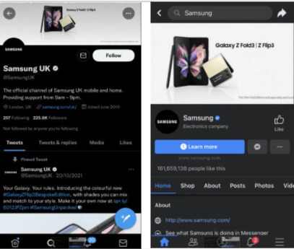

**Audience profile of the company?**

The company Samsung has a target audience of as young as 15 – 45. The reason for this is because they want the audience who follows trends. This is because if their audience are always up to date with contemporary trends then they will buy the latest products. Sales of the latest products can lead the company to make more revenue as well as popularity. Target of audience from 20 – 45 is the most in dept which Samsung look for. I think this is because that is the range in which people have money. Younger than 20, students don’t have a lot of money and may not want to spend it. However, Ages 15 –25 is the age group of smartphone targets. This is because teenagers want to stay up to date with trends and show they have good smartphones. Ages 25+ is mainly target at Samsung Home appliances. Products such as washing machines, microwaves and vacuums are most targeted at this range. This is because they may be moving into new homes and getting their own houses at these ages.

**What format of content does Samsung use?**

Content formats can be seen as a way of boosting your social media audience or followers. A few ways in which companies can create content format are by:

* Posting blogs
* Articles
* Research
* Video and images
* Quizzes/polls
* Surveys
* Email newsletters

For example, the company can use surveys asking their audience which color's they prefer and with the results they can create a new product with this color.

Samsung uses Twitter and Facebook very similarly to post content. An example of this is when you open Facebooks Samsung page. You can clearly see their company name Aswell as their 161 million user likes. Like Twitter, you can see that they use their cover image to promote and specify their upcoming products. On Samsung's Twitter page they also use this same strategy. I can show you a screenshot as evidence.

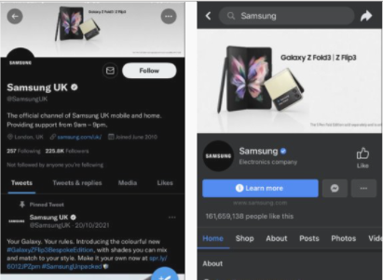

Above is a screenshot which I have taken of Samsung on Both platforms Facebook and Twitter. On the left is Twitter and on the Right is Facebook. Yes, they both look similar, this is because like I said before on both platforms, they promote products on the cover page.

**Advertising Features?**

Any company needs to have some sort of advertisement to see success. This can be through online advertising, call advertising, print advertising, public and outdoor advertising. An example of online advertising would be posting online. This is often done through social media. Simply by uploading videos or posting images. Call advertising can be a bit difficult, but it also works. Examples of call advertising are usually done when ordering through a phone call. An example could be if someone is calling up for insurance, the company can advertise one of their offers. Print advertising can link with public advertising. This is when you print out a leaflet or poster promoting your product. A notable example of this is with takeaways because they print out posters and leaflets of their menu and post it to you or stick it up in public places. Finally outdoor advertising is widely used on billboards. I will create an asset with examples of each.

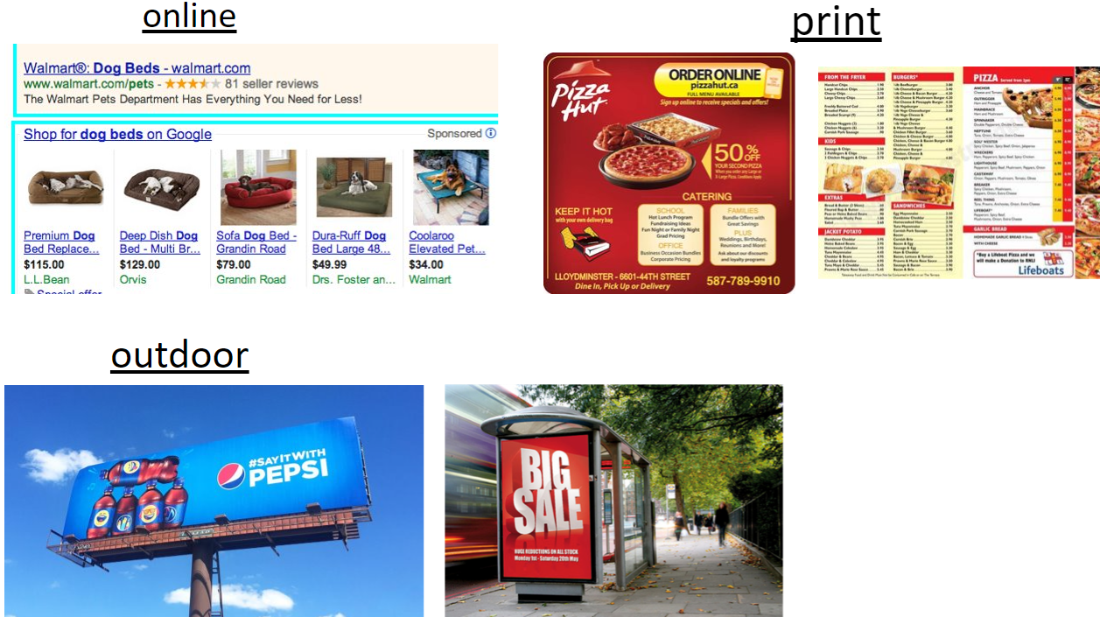

**How does Samsung advertise?**

Samsung uses online advertising as well as social advertising. The way they advertise online is by creating advertisements and videos which they publish on television. They also create Advertisement videos which they publish on YouTube. Samsung has many ads which they post. You can find this by searching on YouTube: Samsung Ad or you may find it before a video or through YouTube double ads. Here is an example of one of their recent online advertisements.

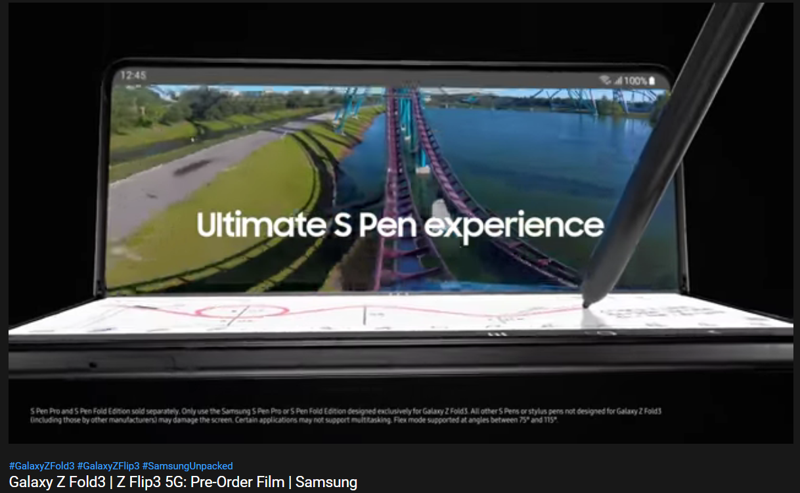

The other way in which Samsung advertise their products is by in-store customer service. The staff at Samsung look out for as many opportunities to offer you one of their products or deals. They do this because it gives them more revenue and more customers.

**SEO**

What is SEO? The word SEO simply stands for search engine optimization. Search engine perfecting means increasing the value of the traffic of the websites which leads to more views. For example, Bing is an example of SEO. When you open the application, you get a lot of suggested searches. Quite a few popular web browsers have SEO. Edge and Google both have search engines. They have search engines to advertise and inform you about trending news. Samsung has its own search engine for all their mobile users. This can’t be installed on iOS devices, but it is already installed for android devices. I will supply a screenshot of what the icon looks like.

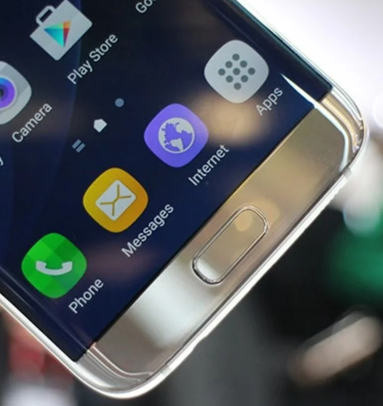

Comparing Samsung to apple they both have their own search engine built into their device. However, on any iOS platform you have safari.

**Audience development and Keywords**

The meaning of Audience Development is simply attracting your audience towards you. One way many stores do this is by having sales. For example, if JD was having a summer sale on their products, then you are most likely to see some sale signs. Her is a few examples.

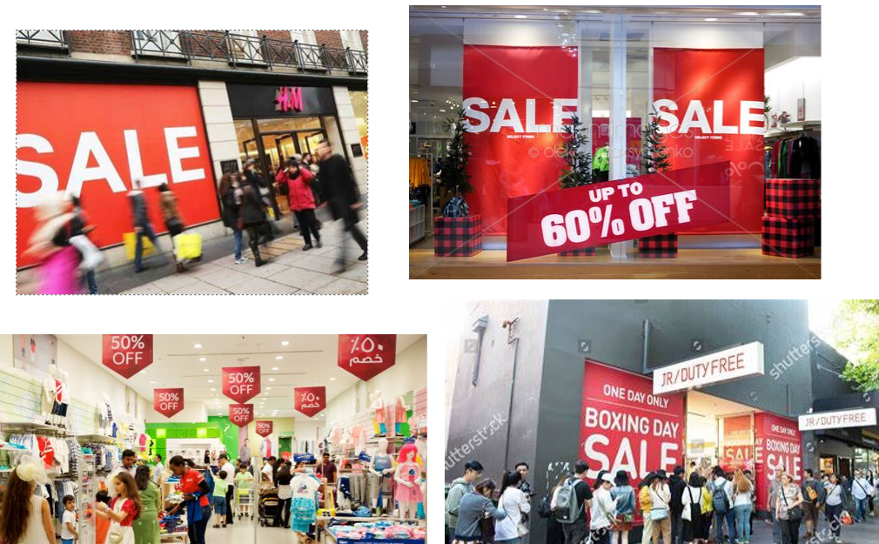

Many stores use these big signs as a terrific way of audience development. However, Samsung doesn’t. In fact, Samsung sometimes do have small signs near products showing they are on sale; however, they don’t have signs outside their store. This is a big disadvantage because now people outdoors are unaware of their sale and may not notice and walk past. However, I think if they did have sale signs outdoors, they could attract a lot more customers to walk into their store. Instead of this method Samsung create posters and flyers which they may use on doors outside their store. You can see some examples of their appearance here.

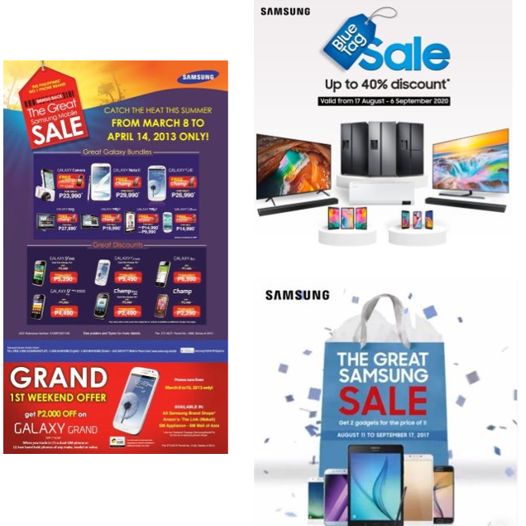

A keyword is when you use a word to define your page. Samsung doesn’t really use keywords for promotions. They're for I think they once again can be at a disadvantage, however because they are a big company, I also don’t think it affects them too much. Keywords are crucial for small companies who are struggling to grow their businesses. Having keyword promotions as a small business can give you a boost against your competitors.

**Indirect or direct advertising**

As I mentioned slightly before, Samsung advertises in many ways.

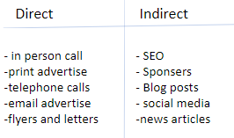

here is a table which I have created of some examples of how companies can use direct and indirect advertising. Samsung uses a few of these. For example, when you call them up, they always offer you some of their deals this clearly shows direct advertising. An example of indirect advertising would be posts of their products which they post on social media. Here are some examples of indirect advertising.

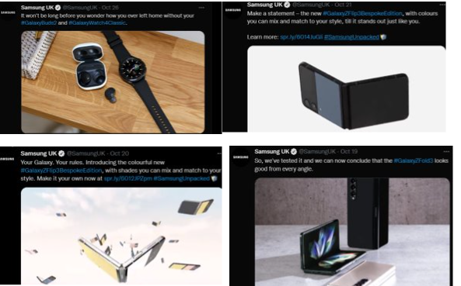

**How do they get customers from social media to their website?**

The only way any company can get their customers to go from social media platforms straight to a website is from a direct link. Samsung successfully does this on their social media apps by adding their online webpage hyperlink to their social media profile. I will show you a few examples.

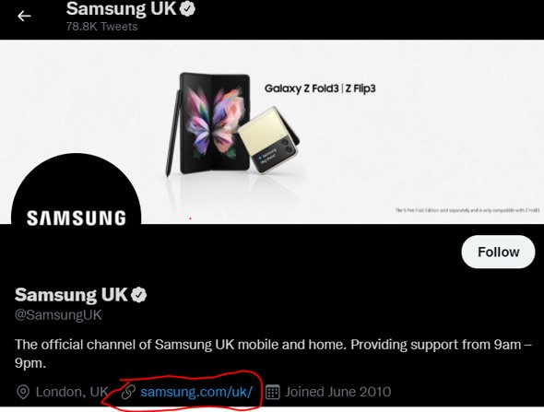

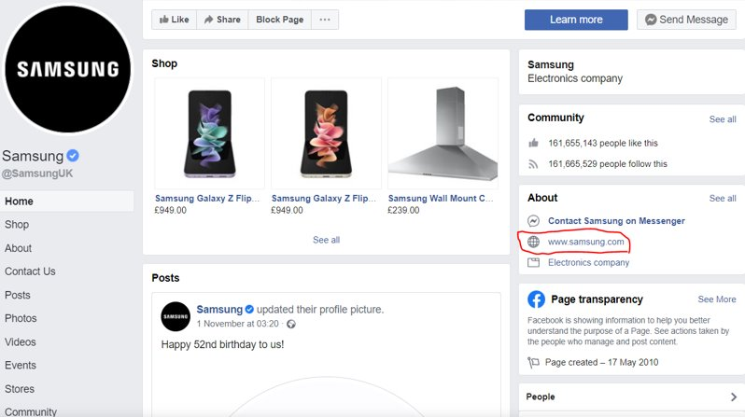

**Do they face any risks?**

Three fundamental areas which Samsung is facing threats are: competition, legal restrictions and imitations of consumer products.

* Competition is one of the highest risks which Samsung is facing. They are currently in competition with other major companies such as Apple, Lenovo, LG and Google. If anyone handles reducing customers and sales from Samsung, then there is a high probability it is one of these companies.
* Legal restrictions Is also a factor which targets the company. This is especially high in mobile and smart technologies. This is because there are a lot of laws in place with smart devices and mobiles and lots of restrictions in place.
* Imitation is an example of risks for companies. A big example of this is when someone creates a similar smartphone and sells it a lot cheaper than the original. The mobile can be sold market price cheaper than the original with the same or at least remarkably similar features. This puts Samsung at huge risk of losing a lot of customers because they will think it’s the same phone just cheaper and they will buy from the other seller.

**How can Samsung Reduce these risks?**

Samsung can simply follow its own ideas and not copy features from other companies. They can also reduce their price ranges, which may help because they can make more sales. Another way the company Samsung can ease competition Aswell as imitation is by following newer technologies and creating newer ideas and designs before others.

**Conclusion**

For Samsung to help their social media usage they should post more. This is because creating more posts leads to higher chances of your post being viewed. Samsung has done well by creating multiple social media platforms. However, they should be more consistent on them and reply to their comments Aswell as engage with their audiences' questions. They should also ask their customers about what they want. For example, if they want touch screen phones or if they want a wider color range for mobiles. They can do this by creating polls or surveys.